Year 11 Set Texts (Cohort 2024)
COMPONENT 1
Magazines | Posters | Newspapers | Adverts | Radio
Pride (July 2021)  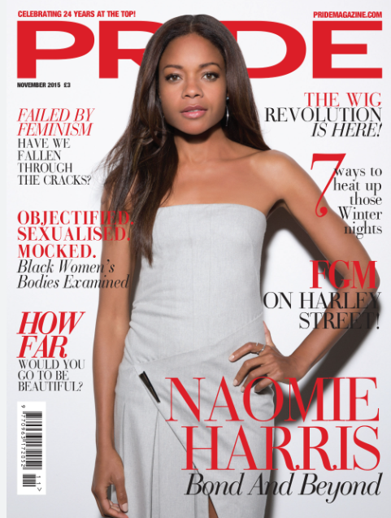 | The Man with the Golden Gun (1974)  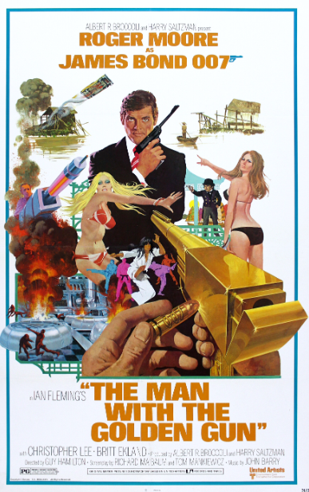 | The Guardian (18 January 2022)  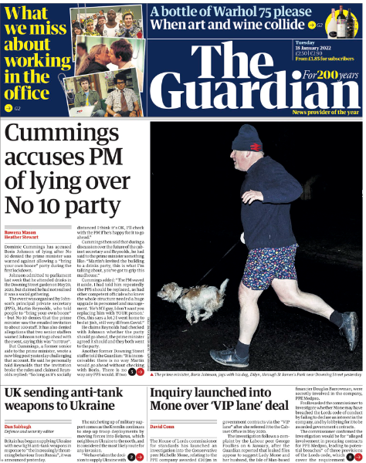 | Quality Street (1956) 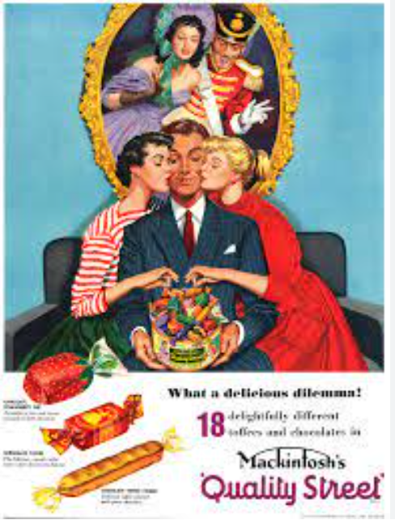 | The Archers  (Radio 4)
GQ (August 2019)  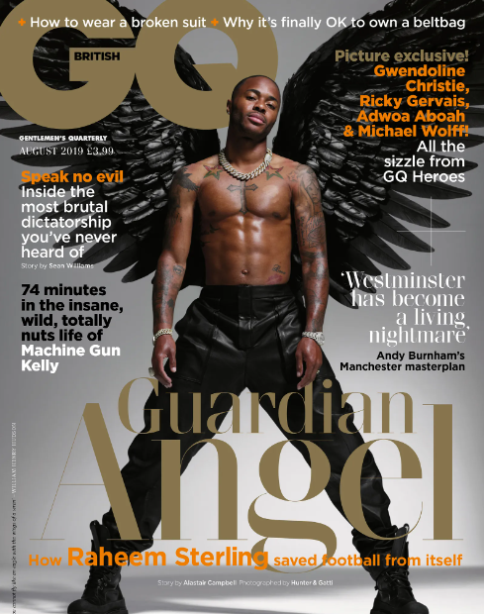 | No Time to Die (2021)  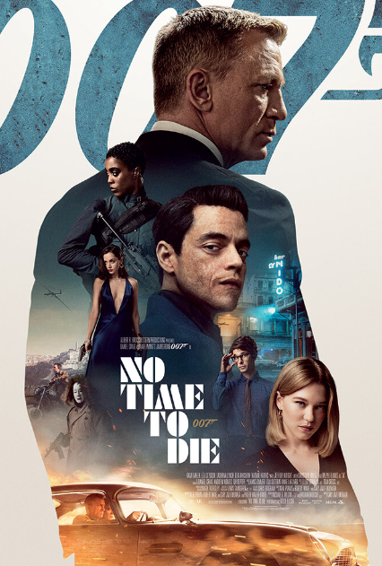 | The Sun (01 January 2021)  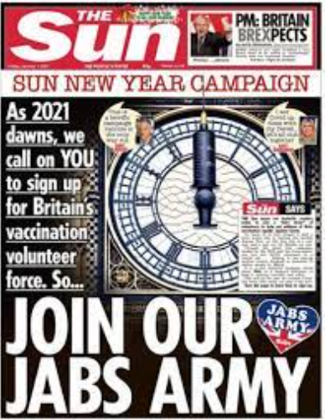 | This Girl Can (2015)  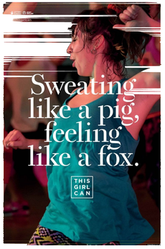 | Gaming
Fortnite
(Epic Games)
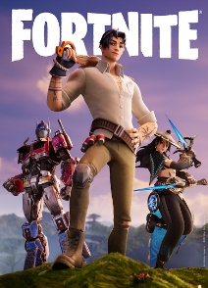

COMPONENT 2
Music | Taylor Swift  (Bad Blood)  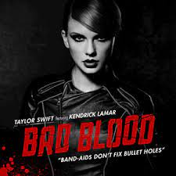 | Bruno Mars  (Uptown Funk)  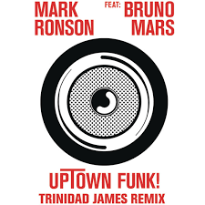 | Duran Duran (Rio) 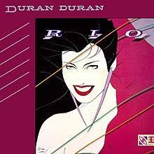
TV Drama | Luther  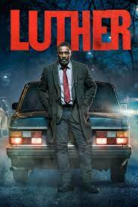 | The Sweeney  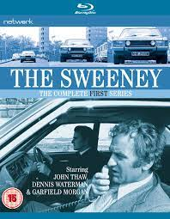

Year 10 Set Texts (Cohort 2025)
COMPONENT 1
Magazines | Posters | Newspapers | Adverts | Radio
Vogue (July 2021)  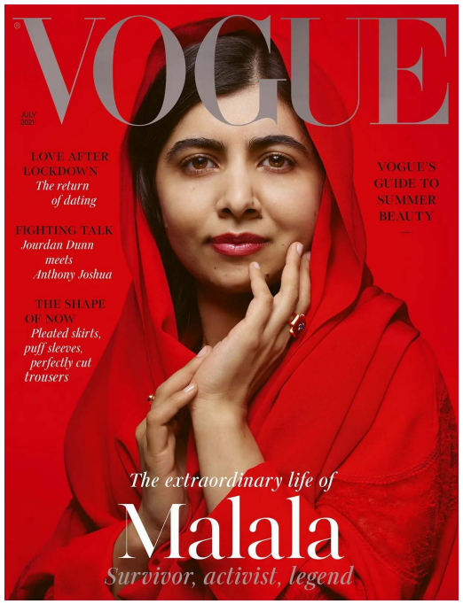 | The Man with the Golden Gun (1974) | The Guardian (18 January 2022) | Quality Street (1956) | The Archers  (Radio 4)
GQ (August 2019) | No Time to Die (2021) | The Sun (01 January 2021) | This Girl Can (2015) | Gaming
Fortnite
(Epic Games)

COMPONENT 2
Music | Either: Lizzo  (Good as Hell)  Lizzo  Or  Taylor Swift  (The Man)  Taylor Swift | Stormzy (Superheroes)  Stormzy  Or  Justin Bieber (Intentions)  Justin | Duran Duran (Rio)
TV Drama | Luther | The Sweeney

