English
Flash Fiction

Flash fiction is a type of story that is much shorter than the stories we’re more familiar with; some pieces of flash fiction are a few hundred words long, a hundred words long and in some cases, a miniscule six words long!
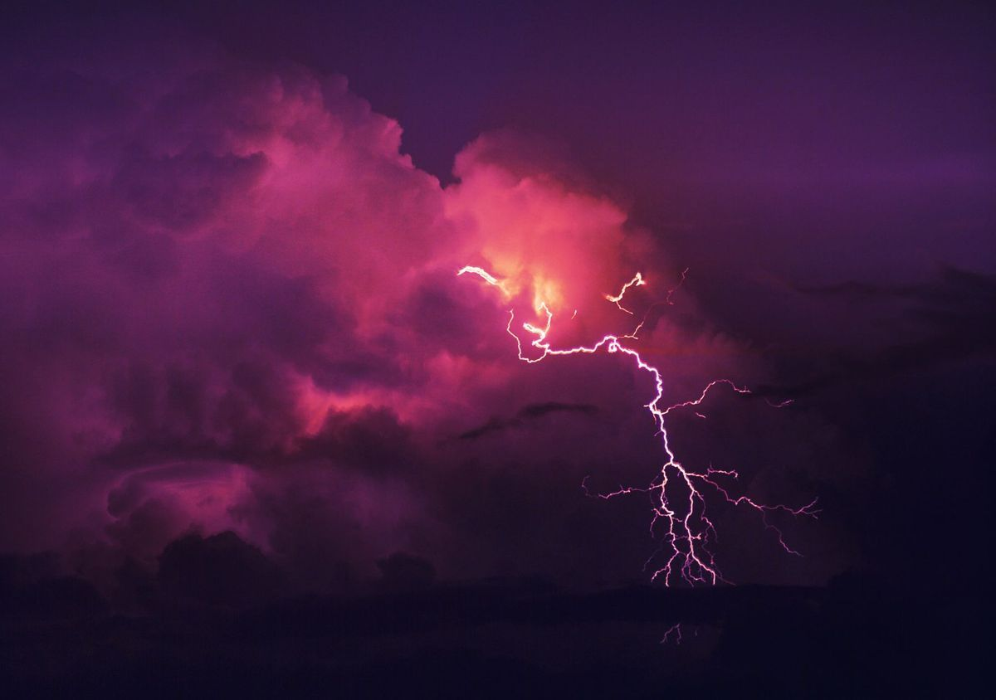
In this booklet, you will read examples of flash fiction and have the opportunity to create your own.
Any idea why it’s called ‘flash fiction’?

Task 1: Fictional Stories
Consider these questions carefully and write an answer for each one in the box provided.
What do all stories need?

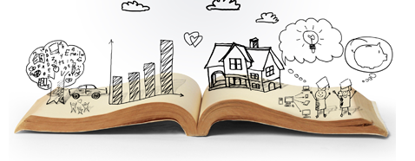
A
How long does a story need to be? Explain your answer.

What kind of stories do you enjoy? (Genre, form, etc.)

What makes a really interesting story?

What is your favourite story?

Task 2: Six-Word Stories
The six-word story is a type of flash fiction and this particular type was made famous by writer Ernest Hemingway who wrote, ‘For sale. Baby shoes. Never worn.’ What does this make you think about? What questions does it make you ask? Is this a story? (Explain why it is / isn’t.) Write your answers and thoughts in the box below:
Read the following texts carefully and for each one write down what you think is happening in each text.

A cry rings out; life begins.

______________________________________________________________________________

Church. Ring. Groom. “Where is she?”

______________________________________________________________________________

“Freeze! Don’t move!”
“I just - ”
Bang.

Task 3: Flash Fiction
Read the following example of flash fiction and answer the questions that follow:
I made her test the GPS in the park before she went. I walked with her, counting the degrees, checking the GPS direction against the compass. I found the weather forecast, printed out maps. I charged her phone for her – arranged a system of communicating, grilled her about risk assessments. I made her promise not to go too deep into the hills if it was foggy... or rainy... or icy.
"Be careful," I said. And: "Take care of yourself." Worrying.
Who would have thought that after all it would be me that was in danger? A week-old ham waiting to finish me off. Me lying on the floor, with no system of communicating, no phone, no map.

Is this a story? Explain your answer.

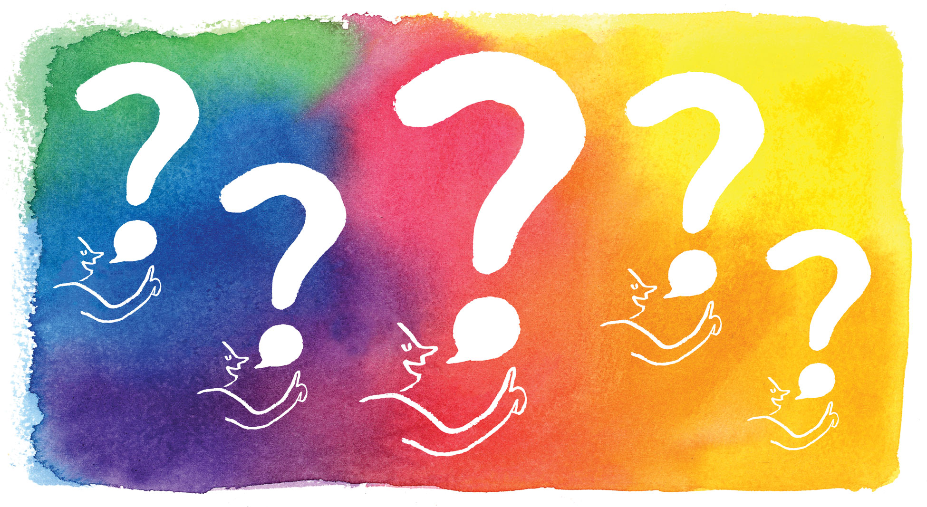

What makes this story interesting?

Task 4: Over to you! You are going to write your own piece of flash fiction. Choose one of the ideas below to write about (or come up with your own!) and write a one hundred word story.
Story Ideas:
It’s the first day of school and your character finds a surprising note on their desk. | While cleaning out the attic, your character makes an interesting discovery. | Your character is at home on a rainy night when they suddenly receive a mysterious phone call.
A day at the beach takes an unexpected turn when your character loses something precious. | Your character is on a school trip to the local museum when an exhibit comes to life. | Your character is forced to face their greatest fear.
Use this grid to help you write as close to one hundred words as possible.

Remember – your story must have a beginning, middle and end.
Write your story out neatly below:
________________________________________________________________
________________________________________________________________
________________________________________________________________
________________________________________________________________
________________________________________________________________
________________________________________________________________
________________________________________________________________
________________________________________________________________
________________________________________________________________
________________________________________________________________
________________________________________________________________
________________________________________________________________

